# **TASK 02**

#### Create a user research, persona creation & journey mapping (SMART WATER BOTTLE)

# USER JOURNEY MAP

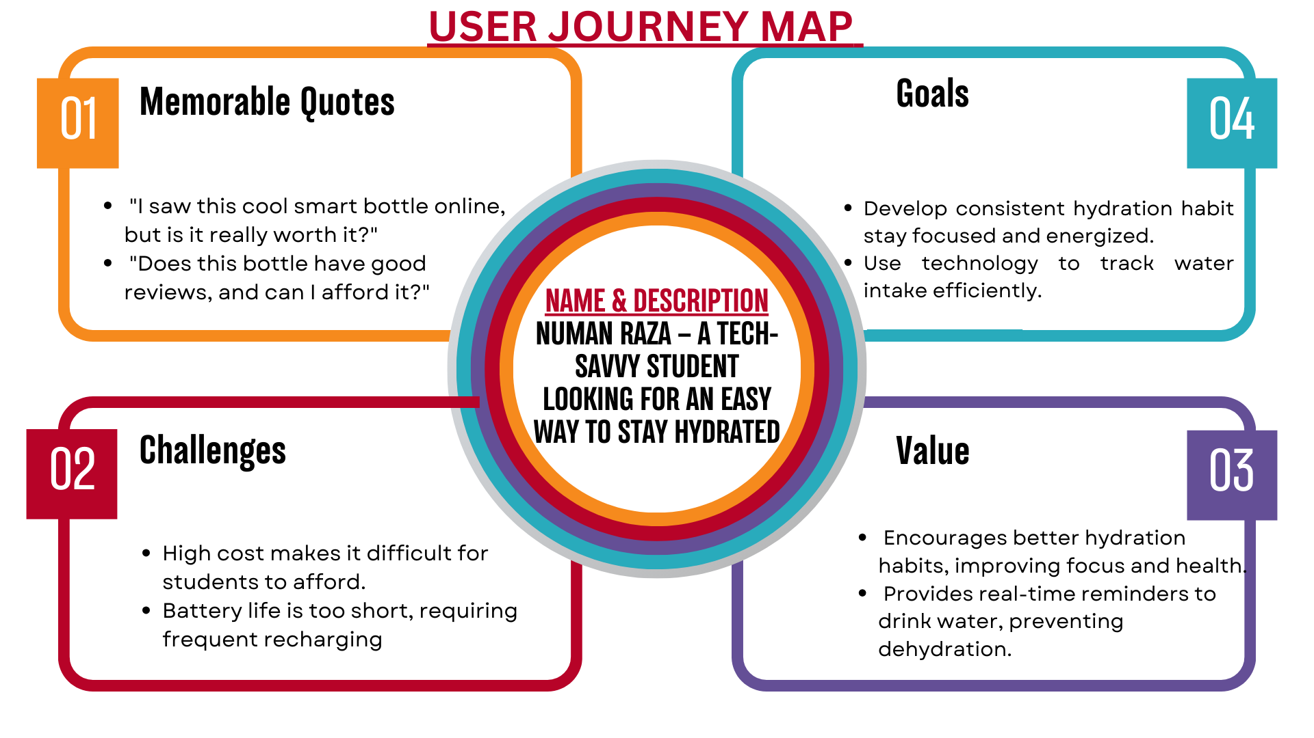

# USER RESEARCH

## **1. Research Objective**

**Goal:** Understand why users stop using smart water bottles and identify improvements to enhance engagement.

## **2. Research Methodology**

|  |  |  |
| --- | --- | --- |
| **Method** | **Participants** | **Purpose** |
| **Survey** | 100+ users | Identify usage patterns and pain points |
| **Interviews** | 10 users | Gather deep insights into user experience |
| **Competitor Analysis** | 5 top brands | Compare features and user feedback |

## **3. Key Findings**

### **User Pain Points**

* Short battery life
* Annoying notifications
* Inaccurate tracking
* High cost, low perceived value

### **User Suggestions**

* Wireless charging for convenience
* AI-driven smart reminders
* Better integration with fitness apps
* Improved ergonomic & spill-proof design

## **5. Recommendations & Next Steps**

|  |  |
| --- | --- |
| Improvement | Benefit |
| Wireless charging | Solves battery complaints |
| AI-based reminders | Reduces notification fatigue |
| Accurate tracking | Increases user trust |
| Ergonomic design | Enhances daily usability |

# PERSONA CREATION

## **Demographic Information**

**Persona Name:** Numan Raza

**Age:** 19

**Occupation:** Student

**Location:** Roorkee, India

**Income Level:** No income

**Lifestyle:** Budget-conscious, tech-curious, and academically focused

## **2. Goals and Objectives**

* Stay hydrated during long study sessions and college activities
* Maintain focus and energy throughout the day

## **3. Psychographic Information**

**Interests:** Science, technology, gaming, sustainable living

**Choices:** Prefers budget-friendly and functional gadgets

**Personality Traits:** Curious, analytical, prefers convenience, early adopter of useful tech

## **4. Behavior and Preferences**

* Uses mobile apps for studying and fitness tracking
* Looks for student discounts and budget-friendly products
* Engages with tech communities on social media
* Prefers low-maintenance and long-lasting products

## **5. User Journey**

1. Awareness: Learns about smart water bottles through YouTube reviews and online ads

2. Consideration: Compares features, checks for affordability, and seeks student discounts

3. Purchase: Buys a smart water bottle if it fits within a student budget and has good reviews

4. Usage: Uses the bottle during classes, study sessions, and workouts, tracking hydration via a mobile app

5. Retention: Continues using it if it’s durable, easy to charge, and provides meaningful hydration insights

## **6. Challenges and Pain Points**

* High cost makes it difficult for students to afford
* Battery life is too short, leading to frequent recharging
* Forgetting to carry the bottle results in inconsistent tracking
* Complicated setup and app syncing create a barrier to use